© ABB Limited 2013
This document contains information that is confidential. It must only be used for the agreed purpose for which it is provided. The contents of this document must not be reproduced or distributed in whole or in part without the written consent of ABB Limited or its authorised representatives.

Title | AquaMaster Modbus Subsystem:  Modbus Subsystem Requirements Specification
Distribution | Software Archive
Author | Spring Kunli.Zhou |  | Date | 2012-02-22
Review | Software Architect | Greg Leach | Date | 2012-03-28
 | Jax Yang |  | Date | 2013-03-07
Approved | Software Architect |  | Date
Approved | Project Leader |  | Date
Remarks | 28-03-2012 Reviewed by Greg Leach  17-01-2013 Modified by Spring Zhou  07-03-2013 Modified by Spring Zhou

Contents
1 Introduction 4
1.1 Scope 4
1.2 Definitions, acronyms, and abbreviations 4
2 Overview 4
3 Assumptions and dependencies 6
4 Functional requirements 6
4.1 General Requirements 6
4.1.1 Modbus Slave implementation 6
4.1.2 Modbus Slave application layer 7
4.2 Modbus Slave communication requirements 7
4.2.1 Communication Hardware Mode 7
4.2.2 Communication Protocol Mode 7
4.2.3 Baud rate 7
4.2.4 Parity 7
2 or 1 stop bits. 7
4.2.5 Start bit 7
4.2.6 Stop bit 8
4.2.7 Inter-character timer 8
4.2.8 Inter-frame timer 8
4.3 Modbus Slave application requirements 8
4.3.1 Modbus Slave register 8
4.3.2 Modbus Slave Register Address 9
4.3.3 Modbus Slave parameter access rule 9
4.3.4 Supported standard Modbus Command 9
5 Non-functional requirements 9
5.1 Command Cycle time 9
6 Design constraints 10
7 References 11
8 Revision History 11
9 Requirement Review 11
9.1 First Review 11
9.1.1 Decision of the Review: 11
9.1.2 Check list: 11
9.1.3 Remarks: 12
9.1.4 Defects 12
9.1.5 Changes are proved: 12
9.2 Second review 12

List of Figures
Figure 1: 4-wire top works Modbus Slave Subsystem Context Diagram 4
Figure 2: Use Case diagram for Modbus Slave Subsystem 4

List of Tables
Table 1 Modbus Slave Subsystem Use Case Table 5

Introduction

Scope
This document defines the requirements for 4-wire top works Modbus Slave subsystem. The subsystem is only designed for both the Enhanced version and MinT version on Front-End board and Mother Board of 4-wire top works depended on the variant devcie. It acts as modbus slave and communicates with PC software through common modbus communication protocol.

Definitions, acronyms, and abbreviations
Term | Definition
Modbus Subsystem | Modbus Subsystem includes Modbus Interface and Modbus Slave Stack.
Modbus RTU | RTU (Remote Terminal Unit) mode, each 8–bit byte in a message contains two 4–bit hexadecimal characters.

Overview
The command process and interpret part of the subsystem is a reuse of modbus common component of ABB BUI. The modbus slave subsystem is responsible for management of hardware layer and communication settings, customized application of modbus protocol, mapping of the object-registers and reuse of the modbus common component.

In this subsystem, the hardware layer use RS485.

The relationships between them are shown in Figure 1.
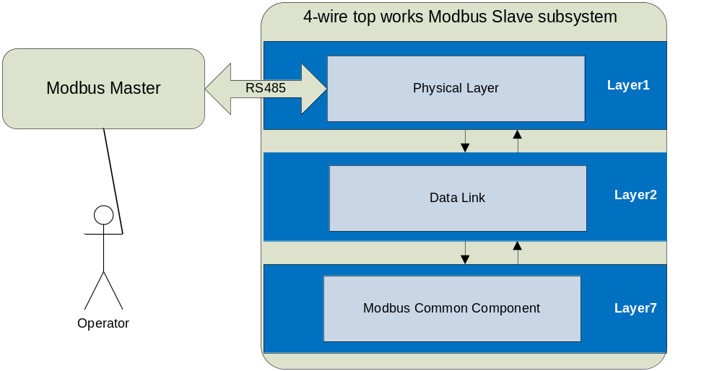
Figure 1: 4-wire top works Modbus Slave Subsystem Context Diagram

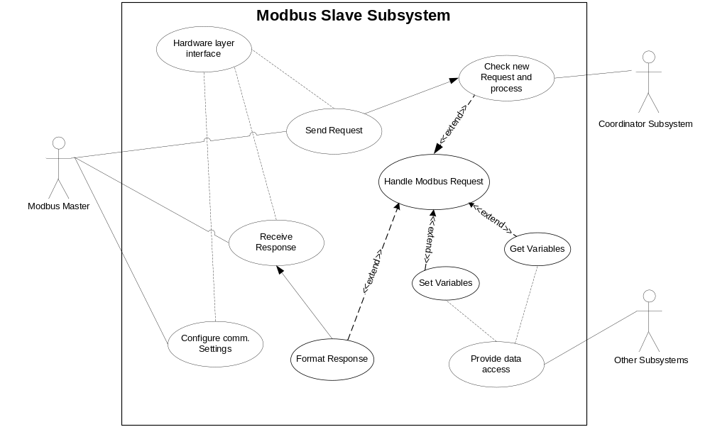
Figure 2: Use Case diagram for Modbus Slave Subsystem

The use case diagram shown in Figure 2 describes the Modbus Slave subsystem behaviors in the scope of the whole system. The external Modbus Master device, as a primary actor, triggers a transaction by sending out a request and receive the response from the Modbus Slave subsystem. The Modbus Master can also configure Modbus Subsystem communication settings, selecting slave address, transmission mode and baud-rate, sets start bits, parity and stop bits. The Modbus Slave subsystem, handles this request and format the response. The hardware interface provides the communication interface for the Modbus Slave subsystem.

No | Use Case | Actors | Description
1 | Configure comm. settings | Modbus Master | The Modbus Master can configure the communication settings of modbus slave, such as baut rate, stop bit , parity bit, etc.
2 | Send Request | Modbus Master | An integral request message is sent from Modbus Master
3 | Receive Response | Modbus Master | The Modbus Master will receive the response from Modbus Slave subsystem
4 | Handle Modbus Request | Modbus Slave | Process the request and give the response
5 | Format Response | Modbus Slave | Format suitable response message
6 | Check Request | Modbus Slave | Check if the request is OK.
7 | Set Variables | Modbus Slave | Some certain variables are updated according to the request
8 | Get Variables | Modbus Slave | Some certain variables are read from the system
9 | Check new request and process | Coordinator subsystem | Check if there is any new request and process the request.
10 | Provide data access | Other subsystems | Provide data access for Modbus slave to set/get variables.
Table 1 Modbus Slave Subsystem Use Case Table

Assumptions and dependencies
The Modbus slave subsystem should in accordance with [3], [4].
Non-volatile parameters of the Modbus subsystem will be managed by the Non-Volatile subsystem.
The data process part in data application layer will reuse modbus common component.

Functional requirements

General Requirements

Modbus Slave implementation
Definition / Motivation | Prio 1 | Source  Development
MODBUS Slave shall be implemented at both the Front-End-Board and Mother Board depends on the device variant.It communicates to an external Master like PLC, SPS or PC EDD.take. | Stability C | Source  Development

Modbus Slave application layer
Definition / Motivation | Prio 1 | Source  Development
Modbus Slave subsystem application layer should reuse the Modbus common component. | Stability C | Source  Development

Modbus Slave communication requirements

Communication Hardware Mode
Definition / Motivation | Prio 1 | Source  Development
Modbus Slave use RS485 as hardware layer to communicate with external Master, asynchronous half duplex communication. | Stability C | Source  Development

Communication Protocol Mode
Definition / Motivation | Prio 1 | Source  4-Wire TRS
Modbus Slave use RTU communication Mode. | Stability C | Source  4-Wire TRS

Baud rate
Definition / Motivation | Prio 1 | Source  Development
The following baud-rates should be supported by the Modbus Slave subsystem. 2400, 4800, 9600, 19200, 38400, 56000, 57600 and 115200bps.  The baud rate setting should be stored in non-volatile memory by the Modbus Slave subsystem.  The default baud rate is 9600bps. | Stability C | Source  Development

Parity
Definition / Motivation | Prio 1 | Source  Development
The following parity settings should be supported by the Modbus subsystem. None, odd and even.  The parity setting should be stored in non-volatile memory by the Modbus Slave subsystem.  The default parity bit is Even.  If no parity bit, there should be 2 stop bits  If 1 parity bit, there should be 1 stop bit. | Stability C | Source  Development
Notes: The Modbus byte encoding format should be 11 bytes, that is 1 start bit, 8 data bits, 0 or 1 parity bit,

2 or 1 stop bits.

Start bit
Definition / Motivation | Prio 1 | Source  Development
Only 1 start bit is supported by the Modbus subsystem.  It’s not selectable. | Stability C | Source  Development

Stop bit
Definition / Motivation | Prio 1 | Source  Development
The following stop bit settings should be supported by the Modbus subsystem: 1 bit and 2 bits.  The stop bit settings should be stored in non-volatile memory by the Modbus subsystem.  The default stop bit is 1 bit.  If 1 stop bit, parity should be even or odd  If 2 stop bit, parity should be no parity. | Stability C | Source  Development

Inter-character timer
Definition / Motivation | Prio 1 | Source  Development
The inter-character timer is not compulsory, it will be ensured by the modbus master. | Stability C | Source  Development

Inter-frame timer
Definition / Motivation | Prio 1 | Source  Development
The inter-frame timer should be 3.5 characters time. If the baud rate is higher than 38400bps, then the inter frame timer should fix at 1.75ms. | Stability C | Source  Development

Modbus Slave application requirements

Modbus Slave register
Definition / Motivation | Prio 1 | Source  Development
The Modbus slave subsystem register table should be arranged to allow standard commands to access all of the indexed parameters. Below table shows the structure at the uppermost level which has the same device address definition with micro motion. | Stability C | Source  Development
  Device Address | Custom Command Address | Description
  1 .. 10000 | 0 .. 9999 | Coils (outputs)
  10001..20000 | 10000 .. 19999 | Input coils
  30001..40000 | 30000 .. 39999 | Input registers
  40001..50000 | 40000 .. 49999 | Holding registers

Modbus Slave Register Address
Definition / Motivation | Prio 1 | Source  Development
The Modbus slave shall use the same register-object addresses as micro motion. | Stability N | Source  Development

Modbus Slave parameter access rule
Definition / Motivation | Prio 1 | Source  Development
All parameters which are access able by customer over HMI shall also be access able over MODBUS slave. | Stability C | Source  Development
Definition / Motivation | Prio 1 | Source  Development
Parameters accessible at Service level will be prohibited for both MinT and Enhanced. | Stability C | Source  Development

Supported standard Modbus Command
Definition / Motivation | Prio 1 | Source  Development
The standard command supported are shown in table below. | Stability C | Source  Development
  Command ID (Hex) | Description
  0x1 | Read coils
  0x2 | Read discrete inputs
  0x3 | Read holding registers
  0x4 | Read input registers
  0x5 | Write single coil
  0x6 | Write single register
  0x8 | Diagnostics
  0xF | Write multiple coils
  0x10 | Write multiple registers
  0x11 | Report slave id

Non-functional requirements

Command Cycle time
Definition / Motivation | Prio 1 | Source  Development
The Modbus subsystem should be able to complete a command request within 125ms. | Stability C | Source  Development

Design constraints

References
Ref. | Document
[1] | Technical requirement specification 4-wire platform_2011-09-09.pdf
[2] | 4WCTW Software Requirements Specification_2011-08-26SN.doc
[3] | Modbus_Application_Protocol_V1_1b.pdf
[4] | Modbus Over Serial Line V1.02.pdf

Revision History
Rev. | Description of Version/Changes | Primary Author(s) | Date
0.1 | Initial revision | Spring Kunli.Zhou |  | 2012/02/24
0.2 | Reviewed by Greg Leach  Confirmed by Simon and Herald by email | Spring Kunli.Zhou |  | 2012/03/28
1.0 | Modified by Spring  The hardware layer will not use Comport subsystem interface | Spring Kunli.Zhou |  | 2013/01/17
1.1 | Modified by Spring  After review by Jax Yang | Spring Kunli.Zhou |  | 2013/03/07
1.2 | Adapted according the review comments. | Zuochen Wang |  | 2016/07/04

Requirement Review

First Review

Decision of the Review:
 | Decision | next steps
 | Inspection passed without restrictions | Phase finished
X | Inspection passed with restrictions | some changes must be done
 | Inspection not passed | Inspection must be repeated

Check list:
 |  | yes | no | N.A.
1. | Does the specification explain the currently known requirements that the product finally has to perform? | Y
2. | Are complex subjects explained? | Y
3. | Are all used abbreviations and technical expressions explained? | Y
4. | Are all referenced documents in the reference list? | Y
5. | Contains the document a rough overview of the product’s main functionality? | Y
6. | Are all requirements referenced? | Y
7. | Are all requirements testable? | Y
8. | Is the typical environment of the product described? | Y
9. | Is defined which components already exist, will be bought or self-written? |  |  | N.A
10. | Are safety requirements (e.g error-detection, error-handling) specified? |  |  | N.A
11. | Are service/update requirements described? |  |  | N.A
12. | Are all dependencies to other requirement documents considered? | Y
13. | Are templates used in a correct manner? | Y
14. | Are all open issues transferred to the defects table? | Y

Remarks:

Defects
No. | Checkpoint | Description | Major Defect | done  Date
1 | 4.3.1 | The device address definition is in accordance with micro motion. | N | 2012-3-28
2 | 4.3.2 | The Modbus slave shall use the same register-object addresses as micro motion. It’s difficult to do, TBD
3 | 4.2.3,4.2.4 | Change the default baudrate to 19200, default parity to even parity | N | 2012-3-28
4 |  | Delete the inter-character timer requirement which will be assured by modbus master. | N | 2012-3-28
5 |  | Delete the customized command requirement, the PC will only use common command to get all register data. | N | 2012-3-28
6 | 4.3.3 | Add: “for MinT version, parameters accessible at Service level will be prohibited”. Calibration will only be done as a full system with CB. | N | 2012-3-28

Changes are proved:
The Reviewer confirms that all changes are done:
Proved Rev: | Updated to Rev: | Date: | Reviewer:
Greg Leach | 0.2 | 2012-4-12 | Greg Leach

Second review
Project: | 4WCTW
Document under Review: | 4WCTW_Modbus Slave Subsystem Requirement Specification V1.0.doc
Revision: | 0.1
Review Date: | 6/3/2013

Review-Participant:
Dept. | Name
PAMP | Jax Yang
PAMP

Decision of the Review:
 | Decision | next steps
 | Inspection passed without restrictions | Phase finished
X | Inspection passed with restrictions | some changes must be done
 | Inspection not passed | Inspection must be repeated

Changes are proved:
The Reviewer confirms that all changes are done:
proved Rev: | Date: | Reviewer:

Check list:
 |  | yes | no | N.A.
1. | Does the specification explain the currently known requirements that the product finally has to perform? | Y
2. | Are complex subjects explained? | Y
3. | Are all used abbreviations and technical expressions explained? | Y
4. | Are all referenced documents in the reference list? | Y
5. | Contains the document a rough overview of the product’s main functionality? | Y
6. | Are all requirements referenced? | Y
7. | Are all requirements testable? | Y
8. | Is the typical environment of the product described? | Y
9. | Is defined which components already exist, will be bought or self-written? |  |  | N.A
10. | Are safety requirements (e.g error-detection, error-handling) specified? |  |  | N.A
11. | Are service/update requirements described? |  |  | N.A
12. | Are all dependencies to other requirement documents considered? | Y
13. | Are templates used in a correct manner? | Y
14. | Are all open issues transferred to the defects table? | Y

Remarks:

Defects
No. | Checkpoint | Description | Major Defect | done  Date
1 |  | HMI and other subsystem use cases may need to be added in Figure 2 | N | 2013.3.7
2 |  | 4.2.4 and 4.2.6 should describe the stop bit and parity bit in details:  If no parity bit, there should be 2 stop bits  If 1 parity bit, there should be 1 stop bit. | N | 2013.3.7
3 |  | It would be better that if the byte encoding format(11bits) is described in details.  E.g. 1 start bit  8 data bits  0 or 1 parity bit  2 or 1 stop bits | N | 2013.3.7
4 |  | Spell errors:  1)4.2 4.3 “requirments” should be “requirements”  2) 4.2.8 “baut rate “ should be baud rate  3) “Prio” > Priority would be better  4) “hardwarelayer” need a blank space  5) “standared” should be “standad” | N | 2013.3.7
5 |  | It need to speicify that the slave response should meet Modbus specification | N | 2013.3.7

Third review
Project: | Cor_IF + 4-wire
Document under Review: | 4WCTW_Modbus Slave Subsystem Requirement Specification V1.1.doc
Revision: | 1.1
Review Date: | 15.06.2016

Review-Participant:
Dept. | Name
R&D | Georg Horst

Decision of the Review:
 | Decision | next steps
x | Inspection passed without restrictions | Phase finished
 | Inspection passed with restrictions | some changes must be done
 | Inspection not passed | Inspection must be repeated

Changes are proved:
The Reviewer confirms that all changes are done:
proved Rev: | Date: | Reviewer:
1.2 | 26.07.2016 | G. Horst

Check list:
 |  | yes | no | N.A.
1. | Does the specification explain the currently known requirements that the product finally has to perform? |  | x
2. | Are complex subjects explained? | x
3. | Are all used abbreviations and technical expressions explained? | x
4. | Are all referenced documents in the reference list? | x
5. | Contains the document a rough overview of the product’s main functionality? | x
6. | Are all requirements referenced? | x
7. | Are all requirements testable? | X
8. | Is the typical environment of the product described? | x
9. | Is defined which components already exist, will be bought or self-written? |  |  | x
10. | Are safety requirements (e.g error-detection, error-handling) specified? |  |  | x
11. | Are service/update requirements described? |  |  | x
12. | Are all dependencies to other requirement documents considered? |  | x
13. | Are templates used in a correct manner? | x
14. | Are all open issues transferred to the defects table? | x

Remarks:

Defects
No. | Checkpoint | Description | Major Defect | done  Date
1 | 1 | 1.1 Scope (site 3):  Subsystem is also designed for the Enhanced version, not only for MINT | N | 2016.07.04
2 | 1 | Req. 4.1.1:  Modbus Slave will be also implemented at Motherboard. Depends on the device variant | N | 2016.07.04
3 | 12 | Req. 4.2.2:  The Source for this Requirements is the 4-wire TRS | N | 2016.07.04
4 | 12 | Req. 4.2.3:  Default of Modbus Baudrate is 9600 and not 19200.  Further the Source for this Requirements is the 4-wire TRS | N | 2016.07.04
5 | 1 | Req. 4.3.3:  Parameters behind the Service level are not accessible for MinT and Enhanced | N | 2016.07.04

Use Cases specify what happens when actors interact with the system. They specify the intent, not the action detail.
Actors in this context are external entities (people or other systems) who interact with the system to achieve a desired goal.
Priority: 1 = mandatory, 2 = desirable, 3 = future Stability: Commited, Not yet agreed, Likely to change

